

Lab Experiment – 07
Breadth-First Search (BFS)

Aim
To implement the Breadth-First Search (BFS) algorithm for graph traversal.

Objective
To traverse all the vertices of a graph level by level using the Breadth-First Search (BFS) algorithm.

Algorithm
- Start from the source (starting) vertex.
- Mark the starting vertex as visited.
- Insert the starting vertex into a queue.
- Remove the front vertex from the queue.
- Visit all its unvisited adjacent vertices.
- Mark each adjacent vertex as visited and insert it into the queue.
- Repeat Steps 4–6 until the queue becomes empty.
- Stop.

FlowChart
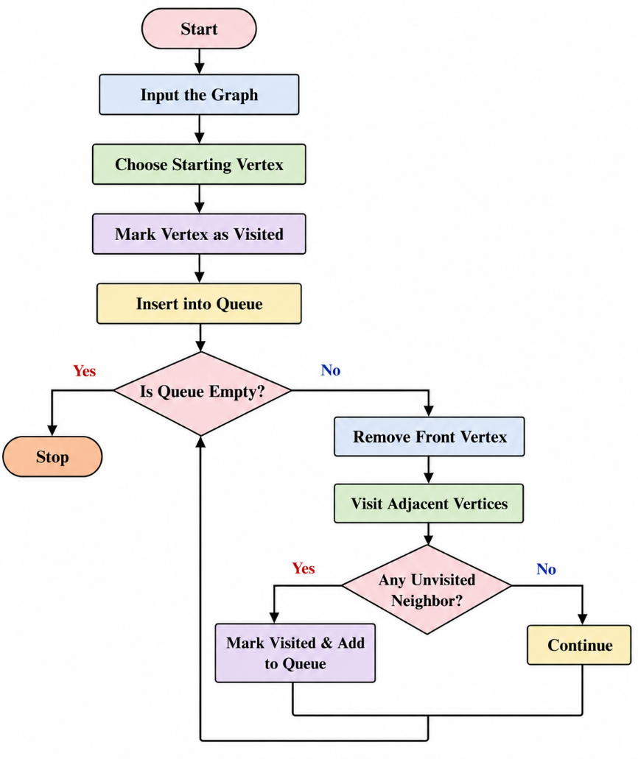
Code:
from collections import deque

graph = {
'A': ['B', 'C'],
'B': ['D', 'E'],
'C': ['F'],
'D': [],
'E': ['F'],
'F': []
}

visited = set()
queue = deque()

start = 'A'

visited.add(start)
queue.append(start)

print("BFS Traversal:")

while queue:
vertex = queue.popleft()
print(vertex, end=" ")

for neighbor in graph[vertex]:
if neighbor not in visited:
visited.add(neighbor)
queue.append(neighbor)
Output
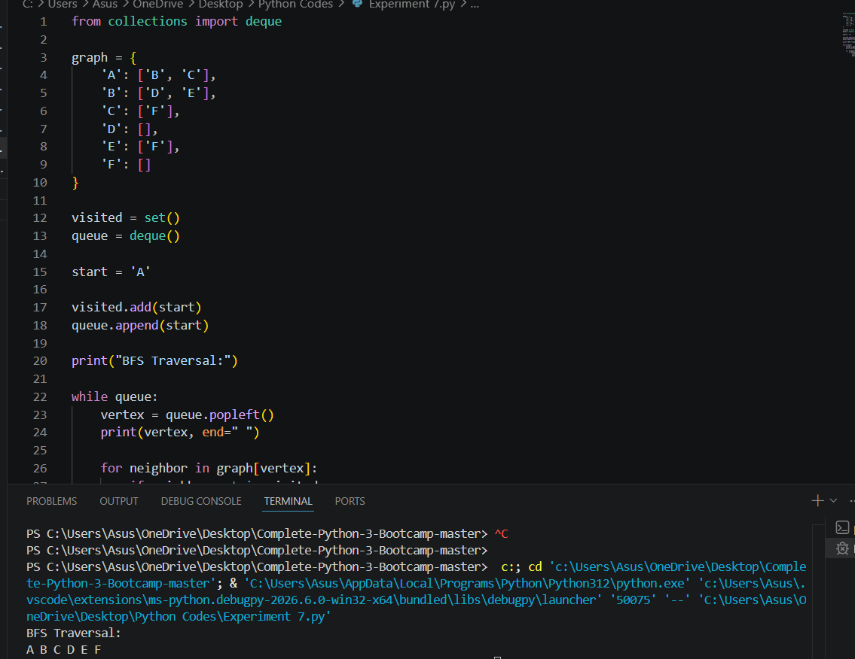

Result
The Breadth-First Search (BFS) algorithm was implemented successfully, and all the vertices of the graph were traversed level by level.

Conclusion
The BFS algorithm visits graph nodes in level order using a queue. It guarantees that all reachable vertices are visited systematically and is useful for finding the shortest path in an unweighted graph.

